Shepherding the Flock – From the June 2026 Session Meeting

Pastor Will’s devotional was a discussion of the faith journey of the 2026 confirmands and a question to the elders about why we made the faith our own (Peter 3:15 Instead, you must worship Christ as Lord of your life. And if someone asks about your hope as a believer, always be ready to explain it. NLT). Several elders shared their experience of making the faith their own.

Reception of New Affiliate Members
Prospective new members John and Barb Dickey reviewed their faith journeys and talked about how they found our church and why they want to be affiliate members. They also hold membership with a Presbyterian church in Venice, Florida. Session voted to unanimously approve their affiliate membership and welcomed them to FPC.

Examination of New Deacons
Session unanimously approved new deacons Ruth Gissel, Jane Grimstad-Kalshoven and Harold Tack. All three shared their faith journeys and what they see as their contributions to the deacon ministry.

Examination of New Elders
Session unanimously approved new elders Phil Greenwood (Stewardship), Lisa Lerdahl (Fellowship) and Brice Wallace (Student Ministry). All three shared their faith journeys and were asked to share one passage from the Book of Confession and one from the Book of Order that were particularly meaningful to them or would guide them in their new roles.

Clerks Report | Lolly Lawrence
- Working with Jamie Roberts to coordinate member check-ins. The deacons already have a plan in place to form connecting groups with our members. They hope to touch base with most members before the end of December. They’ll pass information back to the clerk who will use it to update the member list before bringing to session for further review. The clerk is responsible for keeping member rolls up-to-date in our church register, and also needs to report the correct number of members to the Presbytery (due in January). The clerk also wants to ensure that our member and church friend mailing lists are up-to-date. The deacons’ role in making the contacts is focused on ministry, ensuring that we know our members and have made recent connections with all of them. Jamie will plan to attend the August meeting of session to review their connecting process with the elders and ensure we have alignment.

The deacons will be trained in August. Each deacon will have a mentor aka a “partner deacon” – someone who was previously a deacon and can help guide the new deacons.

- Met with Angela Himegarner to review the Child/Youth/Vulnerable Adult policy. Angela and Joe Madsen have looked through the policy and had comments and questions, which were addressed and resolved. Next step is legal review.
- Compiled results from the listening/brainstorming session meeting in April and received session approval to set the date and plan for the next meeting with the congregation.
- Fall session retreat will be held at Baker Barn in October.
- Thanks to RJ Binau for being “on call,” in case Lolly needed to be out for either the June congregational meeting or session meeting due to arrival of their grandbaby.

Pastor’s Moment | Pastor Will Wilson
- Planning for Pastor Ben’s sabbatical coming up quickly this fall.
- Bill Jones pastoral visits.
- Angela noted that she is meeting with elders and staff. Worked on some policy writing and other planning.
- Recognized outgoing elders – Emily Bauer, Barb Cash, Krista Wallace – and presented each with a gift from the church.
- Wrapping up spring sermon series and beginning work on fall sermons.
- M.M. Lindvall, author of bestselling mystery novel Ashes to Ashes: A Ludington van der Berg Mystery, will be preaching at FPC on November 1. ANSG will be organizing two reading groups. There will also be Q&A with Rev. Lindvall in the community and a fellowship luncheon is being planned around his visit. Prayers requested that everything goes smoothly and this generates interest in the community.

Consent Agenda – Approved

Adult Nurture & Spiritual Growth: Proposed campaign framework as our church begins to prepare for “what/how/when” we celebrate our 150-Year Anniversary in early 2028.

Student Ministry:
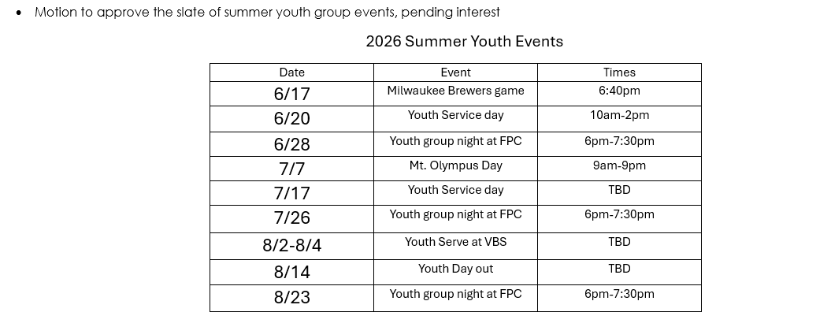

150 Year Planning
Steering committee (Pastor Will, Jim, Monty, and Lolly) provided an update to session along with a short presentation by Jim. Committees are being formed. Expect to launch to the congregation in Fall of 2027, with fall kick-off. The celebration will take place in Spring of 2028. First Presbyterian of Waunakee became a church in February of 1878.

Finance | Monty Cordell
General
- 2025 Audit continues, should have initial report at the end of June
- Reviewed financial report showing where we could run short of capital. Originally, it looked like we could run into difficulties in June, this is now pushed out to August. Contingency plan is in place.
- Reminder that next budget cycle will begin in September.

Ways to Increase Giving/Revenue
- Grow the congregation (currently 20+ net new households). Count of donors (aka families) is 1 less YTD than last year
- Re-engage dormant members
- Provide more giving options (i.e., year-round stewardship)
- Promote faith budget via congregational meeting and article (thanks Barb!)
- Continue to promote Presbytery member dues (per capita). Will include on mid-year member statement
- Legacy giving restarted (18-month rollout)

Reduce General Fund costs
- Use more special funds (shift expense from GF to SF)
- Review special fund definitions during the session meeting and afterwards
- Reduce costs (5% or more)
- Start adding expenses to forecast if these were planned later this fiscal year

Personnel | Rick Mueller
- Session approved the revised part-time worship and music director position description, and approved the hiring of Jamison Wendlandt as our worship and music director based on the revised position description, with a June 13 hire date.
- Session approved maintaining the role of the church pianist and approved Personnel making a request to the Endowment Committee to use $5,000 out of the seed money we pulled from the endowment for the worship and music director, to pay the unplanned expense for the church pianist.
  - (Note, there is an overall reduction in expense from the full proposal, just a shifting of endowment money from the worship and music director position to the church pianist position.)
- Session approved dismissal of the search committee for the worship and music director, with our thanks and gratitude.

Other Submitted Written Ministry Updates

Mission | Leslie Strangfeld
- Members of FPC donated 155 boxes of cereal to the Waunakee Food Pantry—an incredible outpouring of generosity supporting local families during the summer months.
- Planning is underway for the upcoming Pack the Bus mission project with Waunakee Neighborhood Connection, supporting local students and families with back-to-school supplies.
- Mission committee members are reaching out to current mission partners for updates and continued relationship building.

Stewardship |Barb Cash
- On 5/22/26 we put an article in the Connector encouraging online giving to keep the flow consistent and easy.
- An article highlighting the Faith Budget will be published in the Connector coming out on June 19th.

Worship and Music | Amy Lewis
- The Worship and Music director search committee has completed their search. We have selected a wonderful candidate.
- Sam has officially retired from his role as Music Coordinator at FPC as of 5/31/26. He has all the summer service musicians lined up. Please pray that no one cancels, and we have a smooth transition with the new person coming on board.
- Angela will be coordinating efforts to sell some old music equipment and the risers in the music room. She will also try to find a home for the blue hymnals that are still left.

Personnel | Rick Mueller
- As a congregation, we recently celebrated the retirement of Sam Robinson as Worship and Music Director.
- Rick monitored and participated in work of the Worship and Music Director Hiring Committee and met with Amy Lewis and Ruth Gissel to finalize recommendations.
- The Personnel Committee, consisting of Rick Mueller, Brian Wolhaupter, and Keith Kuehn, with the support of Kristina Maher and Angela Himegarner, will meet to do some compliance and policy revision work for FPC.

Adult Nurture & Spiritual Growth | Jim Fitzgerald
- ANSG Ministry Team last met in late April and reviewed status of all Adult Nurture Ministry programs and other special events going forward into 2nd half 2026.
- The Adult Sunday School class (Life Compass), FPC Men’s Group and Ladies Light Team have each concluded studies for the 2026 Spring/Summer semester. 2026 Fall/Winter plans for each are in motion.
- Received request to look at creating a young adult (18-25 age) small group study. Met w/Joe Madsen to review criteria and determined more discussion needed with interested parties re format, timing and next steps.

No Report This Month
Nominating Committee, Children’s Ministry, Student Ministry, Building & Grounds, Fellowship, New Member Outreach.

